St. Francis Institute of Technology, Mumbai-400 103 **Department of Information Technology**

A.Y. 2024-2025

Class: TE-ITA/B, Semester: VI

Subject: **MAD & PWA LAB**

**Experiment – 1a: Study of Dart programming language.**

**1. Aim:** To study the basics of Dart programming language.

**2. Objectives:** After study of this experiment, the student will be able to **●** Learn the basics of Dart language.

**●** Write and execute programs in Dart language.

**3. Outcomes:** After study of this experiment, the student will be able to ● Develop programs in Dart language. (L604.1)

**4. Prerequisite:** None.

**5. Requirements:** Personal Computer, 8 GB RAM, Internet Connection, Web browser. **6. Pre-Experiment Exercise:**

**Brief Theory:**

**Dart**

Dart is an open-source general-purpose programming language. It was originally developed by Google and later approved as a standard by ECMA. It is an object-oriented programming language that bears resemblance to C, Java and Javascript.

Dart language is widely used to develop Android applications, iOS applications, IoT applications and web applications, using the Flutter framework. It supports application development in both client side and server side. A popular example of Dart application is Gmail.

Dart supports essential programming concepts such as variables, loops, arrays (lists), and conditional statements. It provides control flow structures like for, while, if, and switch to manage program execution. Dart also allows developers to work with object-oriented principles like classes and inheritance, and it utilizes a strong, but flexible type system for safer, more readable code.

For asynchronous programming, Dart includes the async and await keywords, enabling non-blocking execution of tasks such as network requests and I/O operations. These features, along with its efficient memory management and optimized performance, make Dart an ideal choice for building scalable applications.

**7. Laboratory Exercise**

**A. Procedure**

**i.** Execute the following programming constructs in Dart.

Statements and variables, data types and return types, decision making and loops, arrays/ lists, functions, classes and objects, inheritance.

**B. Result/Observation**

**i.** Print out of program code and output.

**8. Post-Experiments Exercise**

**A. Extended Theory:**

1. None.

**B. Questions:**

1. Write and execute a basic gaming application using Dart programming language.

**C. Conclusion:**

1. Write what was performed in the experiment.

2. Mention a few applications of what was studied.

3. Write the significance of the topic studied in the experiment.

**D. References:**

1. https://docs.flutter.dev/get-started/fundamentals/dart.

2. https://www.w3schools.io/languages/dart-tutorials/

3. https://www.javatpoint.com/flutter-dart-programming.

4. <https://www.codeproject.com/Articles/754484/Game-development-using-Dart>

CODES:  
  
1. HELLO WORLD  
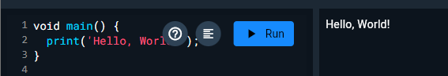  
  
2. Statements and variables

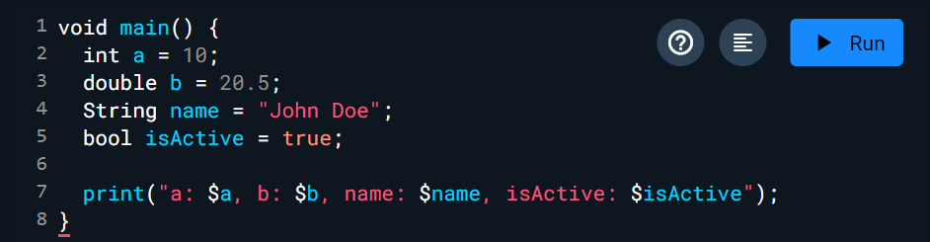  
  
3. Data types and return types  
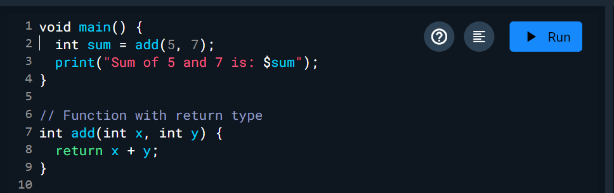

4. Decision making

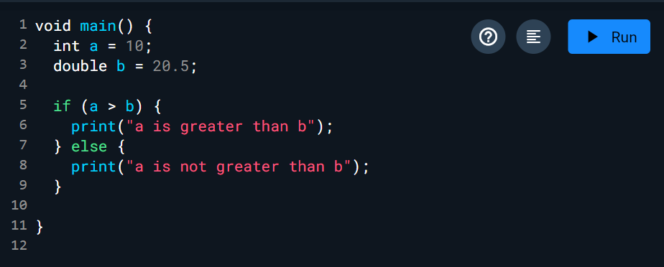

LOOPS:  
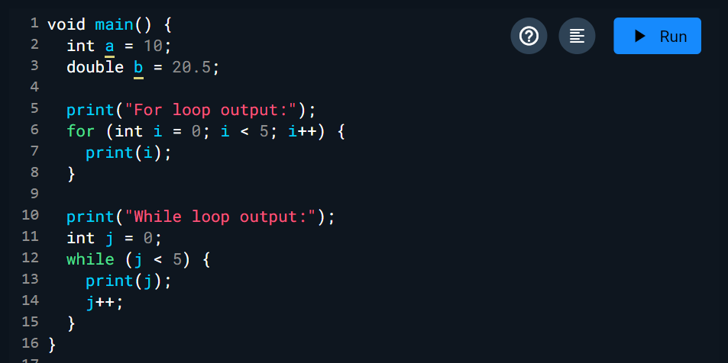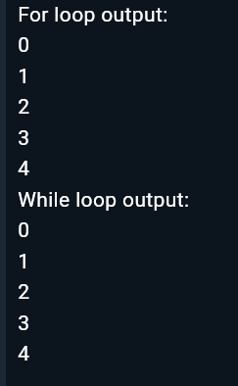

5. Arrays/ Lists

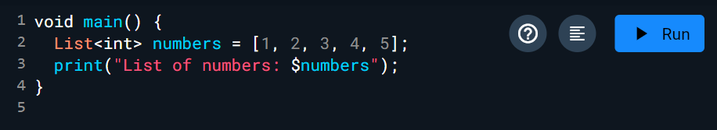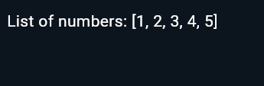

6. Functions

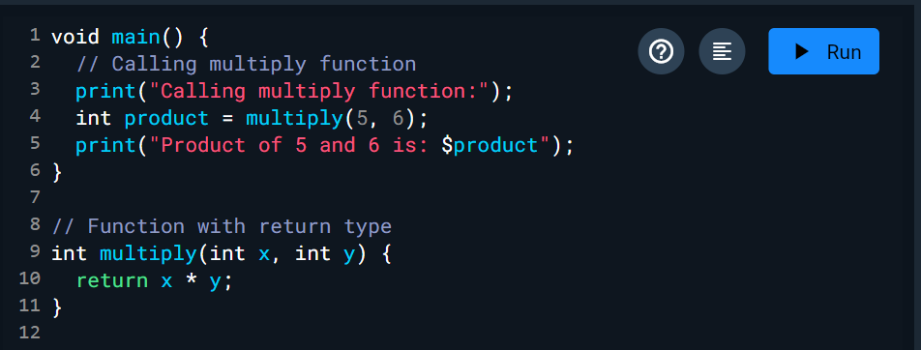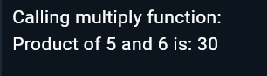  
  
7. Classes and Objects  
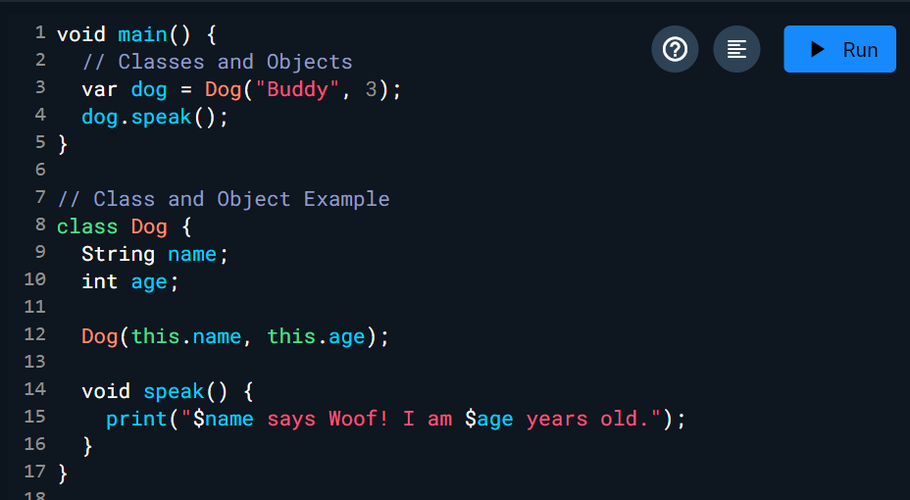

8. Inheritance.

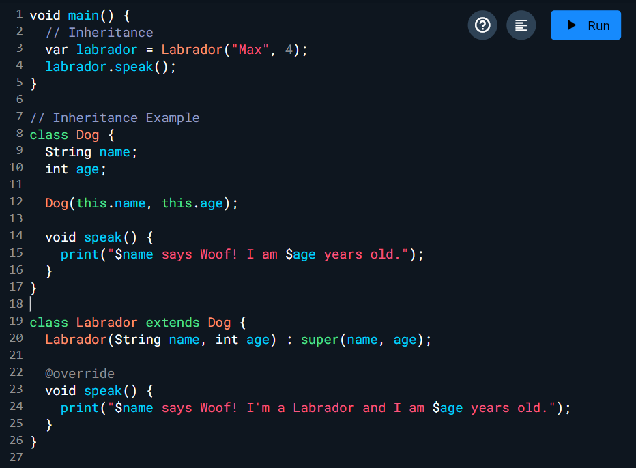  
 **POST-EXPERIMENT:**

B. Questions:

**1. Write and execute a basic gaming application using Dart programming language.**

**CODE:**

import 'dart:math';

void main() {

// Simulating a simple Rock, Paper, Scissors game

print("Welcome to the Rock, Paper, Scissors Game!");

List<String> choices = ['Rock', 'Paper', 'Scissors'];

// Simulating player and computer choices

String playerChoice = 'Rock'; // You can change this to test different outcomes

String computerChoice = choices[Random().nextInt(3)]; // Random computer choice

print("Player chose: $playerChoice");

print("Computer chose: $computerChoice");

String result = determineWinner(playerChoice, computerChoice);

print(result);

}

String determineWinner(String player, String computer) {

if (player == computer) {

return "It's a tie!";

}

if ((player == 'Rock' && computer == 'Scissors') ||

(player == 'Scissors' && computer == 'Paper') ||

(player == 'Paper' && computer == 'Rock')) {

return "Player wins!";

} else {

return "Computer wins!";

}

}  
  
**OUTPUT:**

